*SAVALI -- SHADOW OF THE SPIDERS*

This is a continuation of Ninjas by Blood.

“Hey Akali!” Ezreal, one of the High Councilors, told the Fist of Shadow.

“What?” she replied.

“What?” Elise added.

“Who?” Draven asked, “Why?”

“Read the Ionian news!” Ezreal replied, handing the ninja the newspaper. Akali skimmed through it and said, “Oh Jeez! Savali just ***transformed, AGAIN?!***”

“It’s actually her final transformation, so she’s stable now and will take this form until she dies,” Ezreal said, “That’s what it said. Still half spider, but thinner, slenderer, more agile, quicker, faster, and --- not to mention --- sexier!!!”

Akali slapped him, replying, “YOU’RE MARRIED TO LUXANNA, YOU DOLT!!!”

“Right!” Ezreal replied, “Sorry.”

“Anyway,” Akali replied, “The photographer died looking at her, but he said he looked liked a younger me from the waist up and a spider from the waist down, as usual, but not like before, with that ‘hugeness’. Even he provided pictures of the closest things she looks like now.”

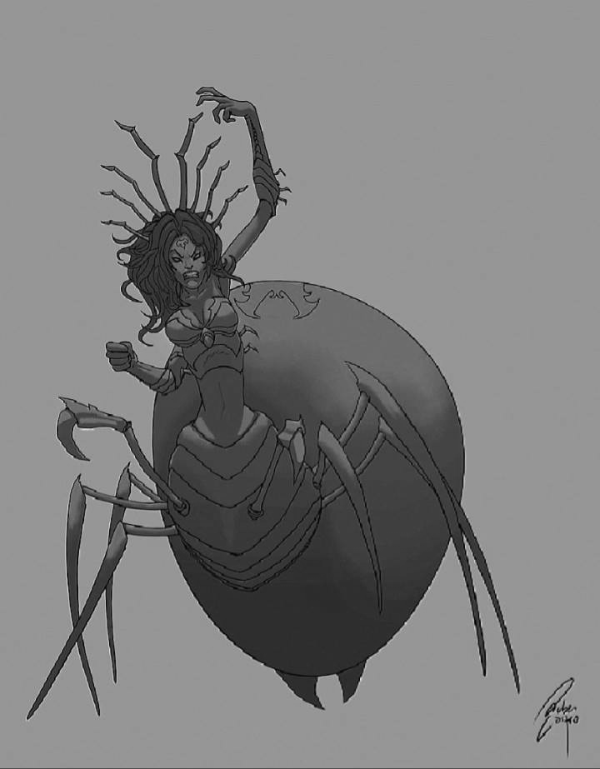

***FIGURES 1 & 2.*** *First picture is what Savali’s face and skin on her upper body could have looked like. Second picture is where her form now is based on.*

“Hmm, she actually looks very good when combined tho’,” Elise commented.

“True, true,” Ezreal replied, “If only she were--- OH MY GOD! SHE’S HERE!”

Everyone looked up from the newspaper and looked towards Ezreal’s direction. Savali in her new form with snow-white upper skin and silver gray lower skin, approached them.

Akali rushed to hug her sister, and she hugged back. “What brings you here?” Akali asked her.

“Just visiting,” Savali replied, “Can’t you believe it? I feel must more active in this final form!” She jumped around the place, and threw one of her front kama-like legs at her sister, who caught it just as swiftly as she could catch flying shurikens.

“That’s cool,” Ezreal replied, “Anyway, you could still make clones, right?”

“Not only could I make them,” Savali replied, “I could ***summon*** them!” She did so, summoning a Clone Sac which looked like Luxanna in front of all the champions present.

“So, what now?” Savali asked.

“Reflection chamber, NOW!” Ezreal replied.

“What?” the spider woman ninja asked.

“You heard him right,” Elise replied, “You’re going to be a champion candidate!”

…

“NoOOOO!!!!!” Savali exclaimed as she was being dragged to the Reflection Chamber by everyone. She used her sharp nails to hold on to the floor as the rest dragged her by the spider abdomen closer to the doors.

“Don’t worry, You won’t be chosen immediately!” Ezreal told her, “It’s a long process, and if you don’t get chosen, at least you tried. Champions find the Reflection part ‘easy’!”

The doors opened, but Savali would not relent. It was only when she saw the Steam Golem that she decided to go inside the doors.

As Savali went out the door with HC Luxanna, Akali asked, “How was she?”

“Welp, she’s okay,” Luxanna replied, “I also had a look-see at her biometrics!”

|  |  |  |
| --- | --- | --- |
| GENDER | F | |
| HP | 550 | 30 |
| HP REGEN | 9 | 3.25 |
| ENERGY | 300 | 0 |
| ENERGY REGEN | 25 | 0 |
| ATTACK DAMAGE | 48 | 3.25 |
| ABILITY POWER | 0 | 0 |
| ARMOR | 20 | 16 |
| MAGIC RESIST | 10 | 8 |
| ATTACK SPEED | 0.635 | 0.015 |
| CRIT. CHANCE | -0.025 | 0.010 |
| RANGE | 500 | |
| MVMT SPEED | 345 | |

LORE

*Savali is a---*

*“NOOOOOO! GET TO THE NEXT PART!!! PLEASE! “*

*But how about---*

*“NOT EVEN A SHORT LORE! ELSE, HELMET BRO GETS IT”*

*Okay.*

*…*

*Whew! She’s gone. Okay…*

*Savali is a ninja by blood, spider by code, and demigoddess by discipline. Having failed the test in which a ninja is inducted into the Kinkou Order, she now works rogue and goes by stealth and deceit. With her sharp appendages, nails, and thread complementing her fast and sleek form, this spider woman is a fighting force to be reckoned with, but she finds the greatest joy when she is with her sister Akali, a sibling whom she was once estranged from but is now found and truly loved with a deep sisterly bond.*

SKILLS

These were told by Garen and Katarina, who underwent training with her as she sparred with them.

*P: Heightened Senses*

Having the senses of both spider and ninja, Savali gains 50 Movement Speed and 25% Attack Speed if and only if she is below 25% health.

*Q: Bladed Threads*

Being physically half-spider, Savali can shoot webs from her spinnerets. She does a backflip and shoots out a glob of bladed thread in the chosen direction, dealing 30/35/40/45/50 (+0.8) damage and rooting up to 4 enemies for 0.25 seconds.

COST: 60 Energy CD: 8/7/6/5/4 seconds

*W: Shukuchi*

If any enemy champions are nearby, Savali pursues the one with the most health, turning invisible, passing through minions and triggering Heightened Senses against the champion for 3/3.5/4/4.5/5. Killing the champion while in *Shukuchi* restores 1.5 times the energy cost.

COST: 55/50/45/40/35 Energy CD: 15/13/11/10/9 seconds

*E: Clone Sac / Life-Sapping Bite*

Savali “lays up” a clone of herself which can be destroyed in two marks or expired in ten seconds. If the sac is destroyed, the spiders slow and mark the minion or Champion. In the next two seconds, she can cast *Life-Sapping Bite*.

*Life-Sapping Bite*: Savali blinks toward the target and bites the neck, dealing 70/80/90/100/110 (+0.35) damage and healing for the same amount.

COST: 55 | 30 Energy CD: 13/12/11/10/9 seconds

*R: Pairwise Attack*

Savali conjures up a fan of 3/4/5 pairs of spiders and kama. Each pair homes in enemies (depending the count) and deals 30/40/50 (+0.5)(+0.5)

combined damage per enemy, up to 90/160/250 (+0.5)(+0.5) combined damage to a single enemy.

COST: None CD: 110 seconds

Well, Savali wanted to end here, so. We’ll see how she fares!